Prepard By

Abdullah Al Bassam

Id: 221311165

Section: E

Semester: 3rd

Dept of CSE, VU

**PREPARED FOR:**

**Ahmed-Al-Azmain**

Lecturer

Computer Science and Engineering

Dept of CSE, VU

December 15, 2022



password generaotr

password encription

password decription

Email validation checker

**Project**

**REPORT**

1.Abstraction:

Our every security system depend on password. Hackers hack by attacking in many ways, one way is brute force, where they take a huge number of list passwords and then try one after another and check. If our passwords are strong and they save in encryption then one hacker has to try very hard to bypass the system. Our system will safe.

2. Introduction:

In this project I am trying to do a few things together. First of all, I will make a password generator for any security issue, it will safer because it will strong password. Here another advantage is user can save password by encryption because of hacking issue if a hacker hacks that file hacker can’t access that password. Here’s more benefit user also can check his email is valid or invalid.

3.Motivation:

Currently our information is not safe from cyber-attacks. We need security system for this. That thought is to create this system.

4.Background Study:

Before deciding about my project, I research and found that in this modern time we need to be safe in internet and for that we have to make strong password. For more safety I generate a random password and make that encryption for more safer so that hacker can’t access that password. Sometime user or a company have to send mail’s so at some point they do not know that mail is valid or invalid. So, this will help them to find out valid emails. spelling checker also help people to find the right spelling.

5.Objectives:

Our main objective is to keep people's information safe and also secure their password by automatically generating strong passwords and encrypting them. If one wants to send a mail, he does not sure whether that email is valid or invalid. In that circumstance user can also check that mail validation in this security system. Main benefit is it encrypt password and safer. More user friendly.

6.Features: More user friendly.

7.Implementation tools:

Programming language: c++

Code editor: Code blocks

Operating system: Windows

8.Flowchart/Diagram:

Input

Switch

Case11

statement

statement

statement

statement

statement

Break

Break

Break

Break

Break

Data

Database

Case21

Case31

Case41

Case51

9.Outputs:

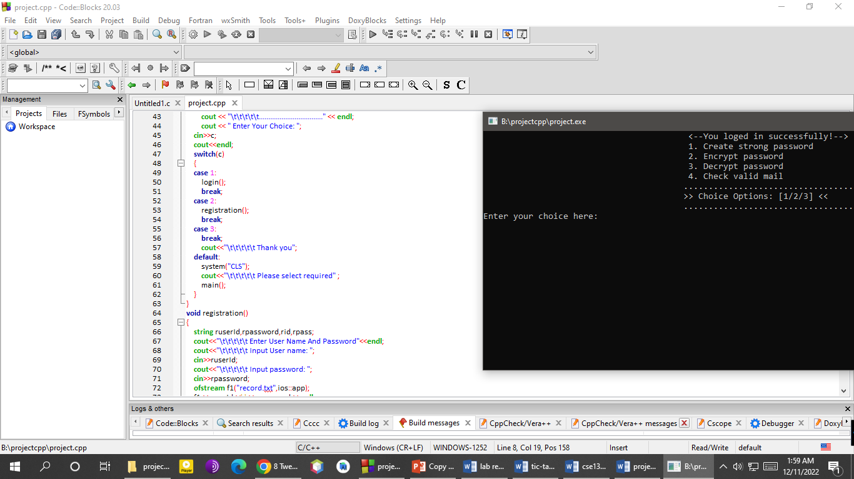

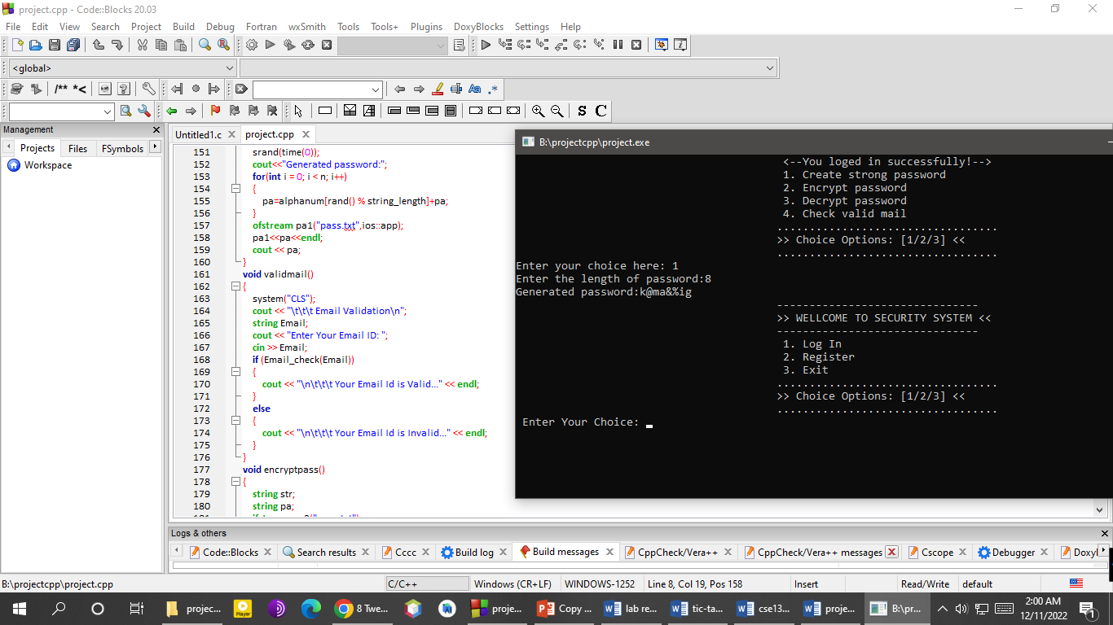

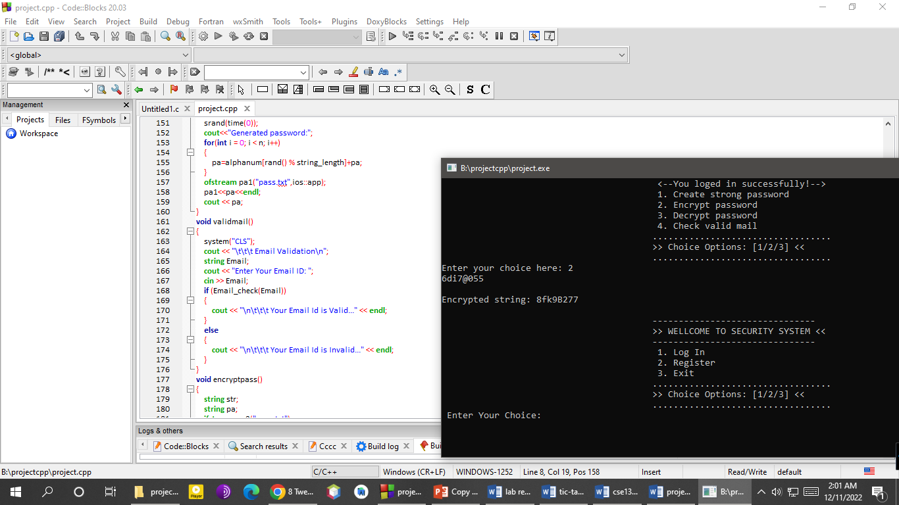

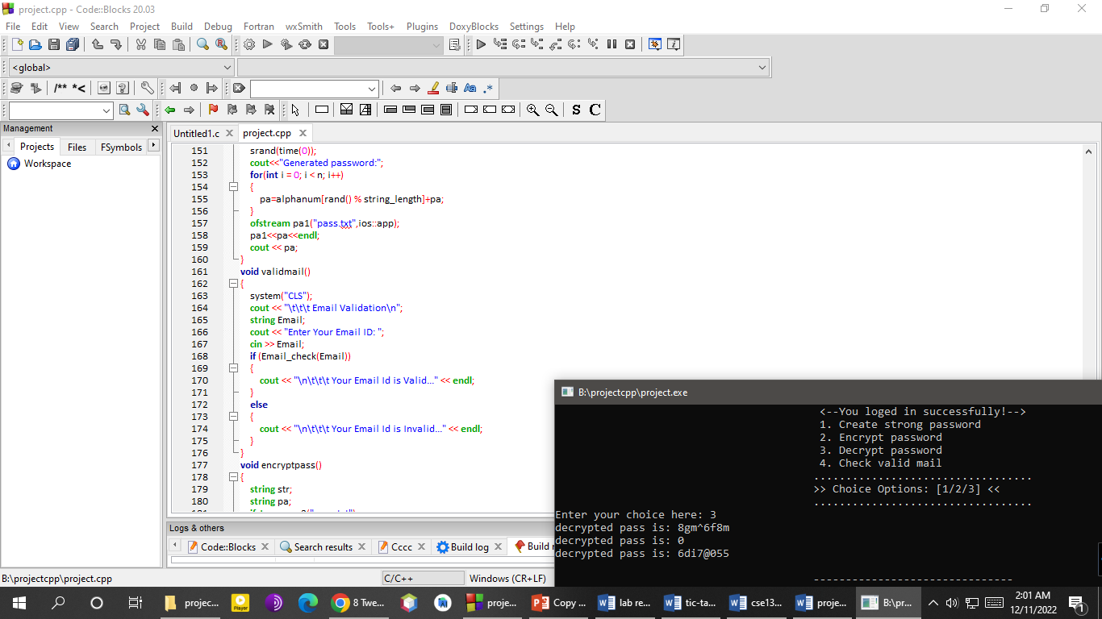

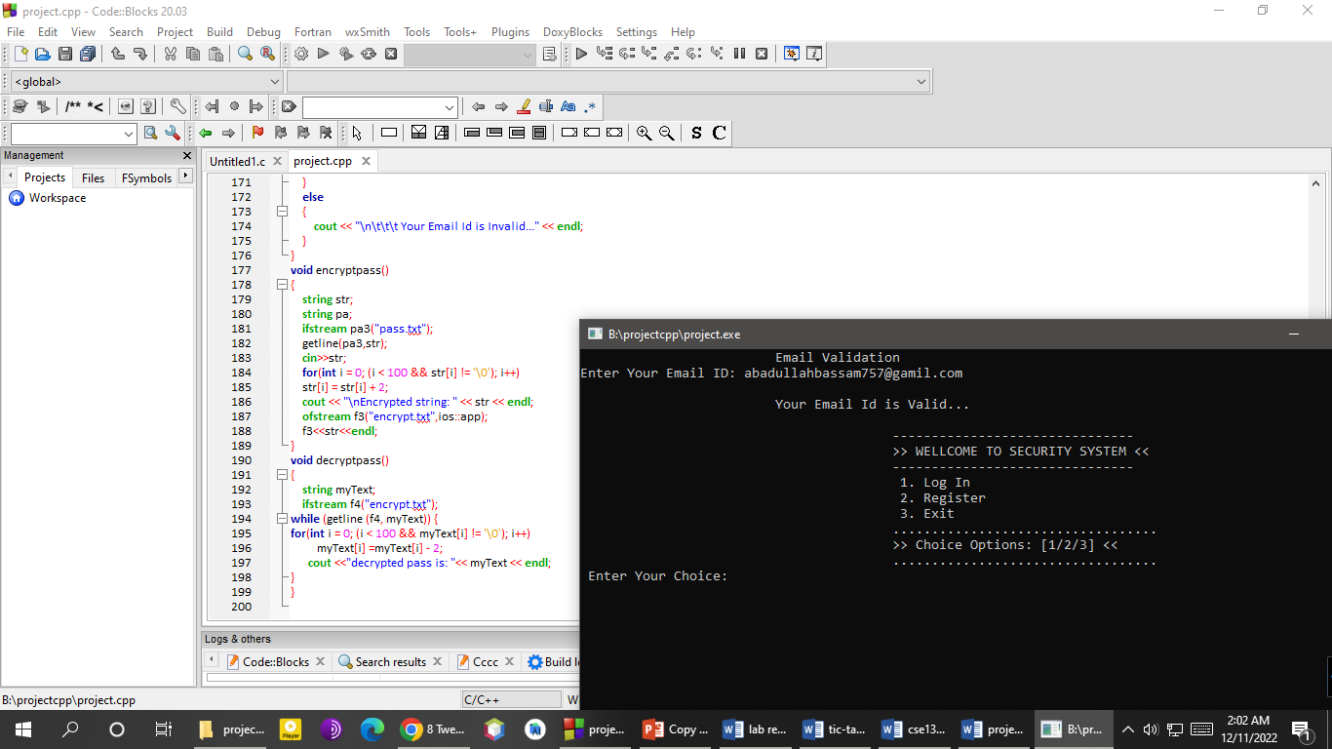

10.Future work:

Will update our system. As new cyber-attacks pose new threats. We will improve our system accordingly. We will make our user interface more friendly.

11.Conclusion:

Cyber security is a process of protecting sensitive data, networks, and software applications from the cyber-attacks. Cyber-attacks can be considered as an exploitation of resources, unauthorized access to the systems, ransomware attacks to encrypt data and extract money. As new attacks are emerging every day, we will update our system accordingly to ensure security.